**Lab 1: Error Analysis and Orientation**

***James Kan, Amari West, Luke Morgan, Gabe Moreno***

**Texas A&M University**

College Station, TX 77843, US.

***Abstract*** *This report covers the concept of velocity and acceleration vector components whilst using their properties to derive the gravitational constant. A tracking camera was used to capture the position of a puck as it accelerated down an inclined air table. The captured position at each frame was then used to calculate the velocity which was subsequently used to calculate the acceleration. Using Newton’s Second Law, the x-component of the gravitational constant was found. Finally, this value and the known angle of the table was used to calculate the magnitude of the gravitational constant. This process demonstrated the mathematical relationship between position, velocity, acceleration, and force while showing how error can present itself during such calculations.*

***Keywords:*** *Velocity, Acceleration, Newton’s Second Law, Gravitational Constant*

1. **Introduction**

The goal of this lab was to find the gravitational constant of acceleration by calibrating a tracking camera. An object needed to be dropped in order to find the gravitational acceleration where the distance at each time from the tracking camera could be found. This would allow for the calculation of the acceleration through calculations based off the change in distance and velocity over time. The data would also contain a value of uncertainty that would need to be calculated to ensure its accuracy towards the gravitational constant of acceleration.

1. **Experimental Procedure**

**A. Description of Experimental Arrangement**

A personal laptop was connected to the side of the platform, which mainly consisted of a level, plastic surface with a grid-like assortment of small holes, from which air constantly flowed onto the surface - creating a sort of air cushion for the relatively lightweight, plastic circular disk with a neon sticker in the center - limiting the coefficient of friction between the disk and the platform to become virtually non-existent, allowing for the disk to slide freely down the incline of the table, with minimal energy lost from contact with flowing air. To assist in calculating the conversion ratio between pixels and centimeters, a meter-ruler was given with two neon stickers centered on particular points of the ruler.

The side of the platform contained an interface a variety of electronic and mechanical components, allowing the air flow of the table to be activated, change the angle of the table, and connect a personal device to the platform. Situated approximately a meter above the table was a small camera connected to the base of the platform, allowing for captures of up to 30 fps of the entire table. The angle of the table was set to 3.6 degrees above the horizontal, with the built-in inclinometer confirming the tilt in the table.

**B. Procedure**(see [here](https://tamu.blackboard.com/bbcswebdav/pid-6307292-dt-content-rid-57308514_1/courses/ENGR.216.2011.M4/216_lab_2%281%29.pdf) for complete and specific instructions)

A personal laptop with a Linux Secure Shell Terminal (e.g. MobaXterm) and an ethernet connection was required to capture the data and the recording of the experiment. Once connected and activated, the required terminal commands, and other commands needed in order to capture and record the data acquired from the camera were inputted.

The procedure to determine the conversion between pixels (px) and SI units (cm) is as follows:

1. It was noted visually that the distance between the *center*of thetwo dots was almost exactly 29.8 cm on the ruler
2. Pink dot center at 40.8 cm along the ruler
3. Green dot center at 11 cm along the ruler
4. On the tracking camera, the (x, y) coordinates of each respective dot in px was recorded while the ruler was stationary, and the distance between the two was calculated
5. Despite the distance being in pixels, the answer was not immediately rounded
6. Because the distance between the two stickers was found in both cm and px, it was possible to compute a ratio corresponding to a quantity of pixels in a centimeter.

To capture the experiment, the plastic puck was held at the top of the incline momentarily within the camera’s view, and released – sliding down until reaching the bottom of the incline, where it was secured by another student in order to ensure it did not recoil upon impact. The disk in question always remained within the field of vision of the camera, or another trial was recorded. Recordings lasted for at least 5 seconds (~180 frames) to ensure adequate data points.

Once the requisite data was acquired, the data, recording, and all other pertinent files were saved to the personal device. The apparatus was then deactivated.

The initial data extracted from the procedure was in the form of a .csv file that listed the x- and y- coordinates of the sticker in the center of the plastic puck, including its apparent size to the camera. With this data, velocity, and acceleration was calculated which was then used to find the gravitational constant along with its uncertainty.

1. **Results and Analysis**

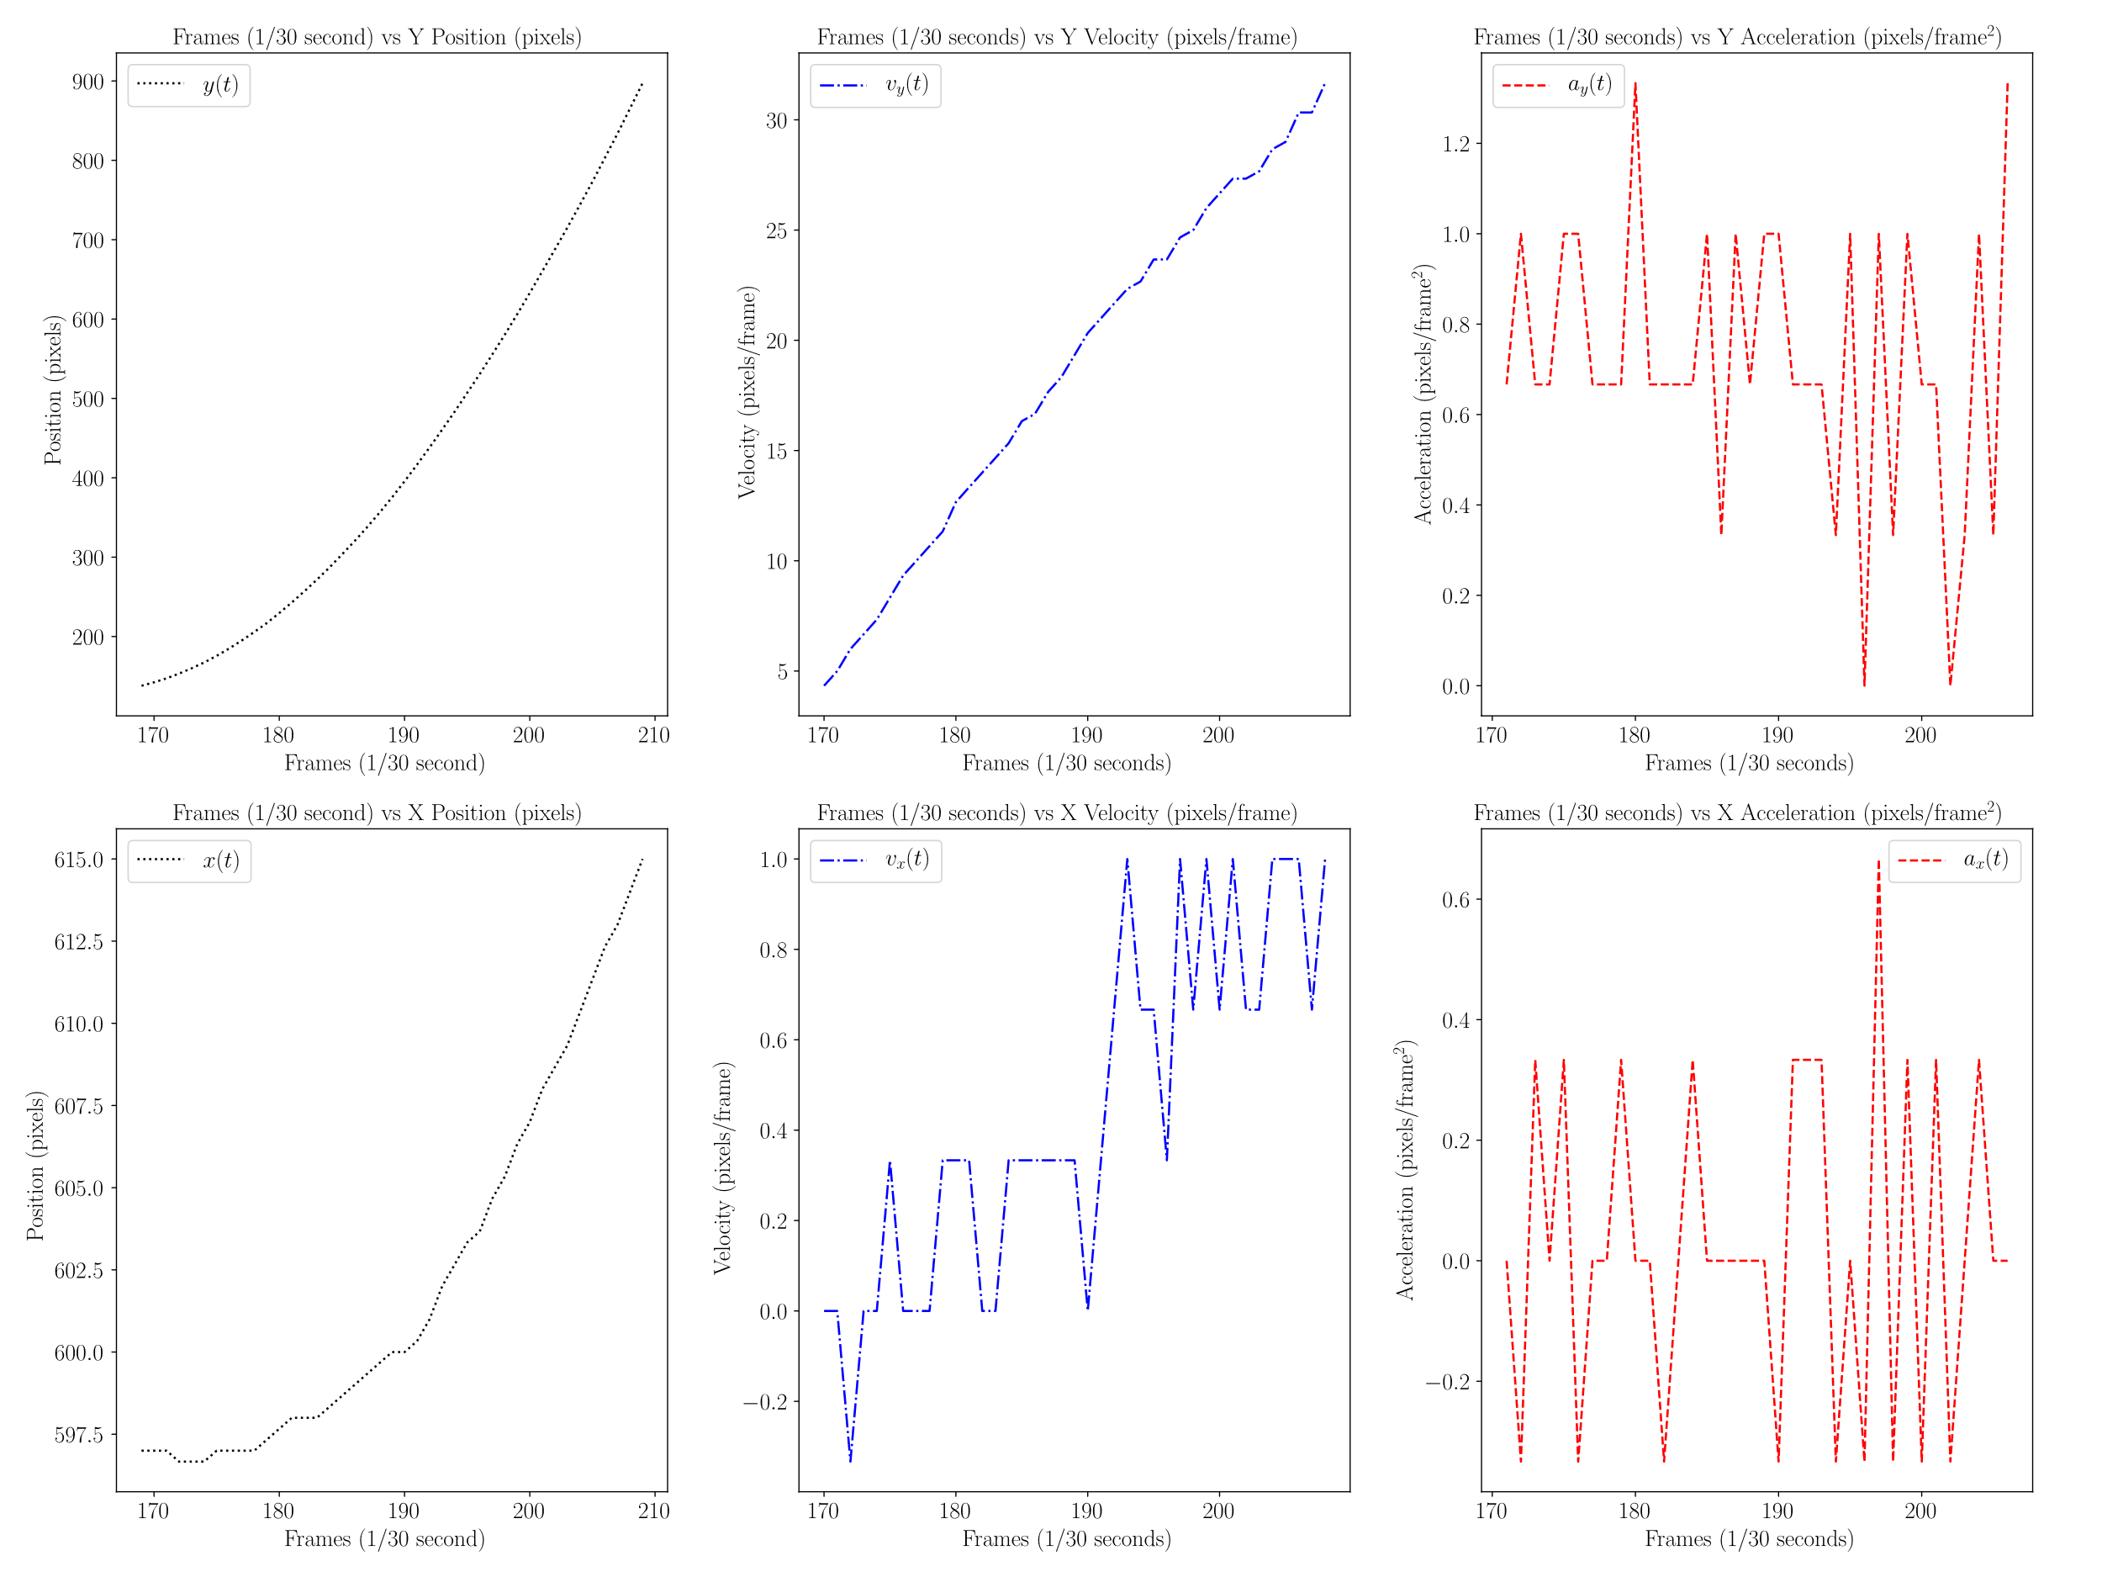

Figure 1: Collection of Graphs of position, velocity, and acceleration in x and y components

Originally, when the raw data was extracted from the .csv file, the data points had to be smoothed using the moving average equation as shown below.

$\overline{x_{i}} = \frac{x_{i-1}+x_{i}+x_{i+1}}{3}$ Equation 1

With the data propagated from this equation, the velocity and the acceleration data points were calculated with the following equations.

$v= \frac{∆x}{∆t}$ Equation 2

$a= \frac{∆v}{∆t}$ Equation 3

Since the physical limitations of the camera tracking inhibited the capturing of a constant acceleration, the average of the data points was recorded as the constant acceleration. According to the average and standard deviation calculations, the average acceleration is 0.709401709 ± 0.269118285 pixels/frame2 or 0.572173519 ± 0.217059466 meters/second2. This value for average acceleration then was used to calculate g by dividing it by the sine of the angle of the incline as shown below.

$\frac{a_{x}}{\sin{θ}}=g$ Equation 4

This yielded 9.112418944 m/s2 with an uncertainty of 4.41274486 m/s2

1. **Conclusions**

From dropping the puck at a constant angle and recording its position at every frame, the average acceleration was calculated by standard deviation of the position through pixels per frame2 to meters per second2, giving a value of 9.112418944 m/s2 with an uncertainty of 4.41274486 m/s2. This experiment proved to be close to the gravitation constant of 9.81 m/s2 yet failed to reach a level of uncertainty that would include the gravitational constant. This was due to the limitations such as the camera having moments where it recorded at 29 frames per second instead of 30.